>
1. Write a Maple procedure (proc) called function(x), which will accept the variable a and x to calculate a function which has a value of 2*x^2+x+a in the range of -a to a, and a value of zero everywhere else. Check your procedure by calling this proc using different values of x and a.
> restart:
> f:=proc(a, x)
local z:
if a>=-6 and a<=6 then
z:= 2*x^2+x+a:
else
z:=0:
fi
end:
> f(3,5);
> f(10,3);
2. Write a Maple procedure (proc) called Grade(marks), which will accept a student's exam mark and returns his grade.
> restart:
> with(Maplets[Elements]):
> f:=proc(a)
if a>85 then
"A"
elif a>70 then
"B"
elif a>55 then
"C"
elif a>40 then
"D"
else "FAIL"
fi:
end:
> f(70);
> f(90);
> f(35);
Write the commands necessary to produce the following maplets:

a) Grader maplet which will accept a student's exam mark and returns his grade.

> with(Maplets[Elements]):
> Grader:=Maplet([
["Student's Exam Mark"],
["Enter your mark:",TextField['Mark']()],
["The Grade is:",TextBox['Grade'](not editable,width='30',height='3')],
[Button("See My Grade",Evaluate('Grade'='f('Mark')')),
Button("OK",Shutdown(['Mark','Grade']))]
]):
> Maplets[Display](Grader);
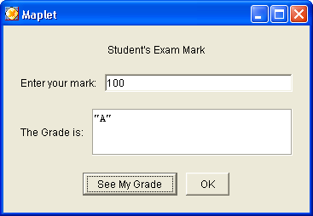

b) Eqsolver maplet which will accept any equation in one variable and give its solutions.

> restart: with(Maplets[Elements]):
> EqSolver:=Maplet([
["Equation Solver"],
["This maplet can help you solve any equation that have one variable"],
["Please enter equation:",TextField['Equation']()],
["Enter the variable to be solved:",TextField['Variable'](1)],
["The answer is:",TextBox['Solution'](not editable, width='20',height='4')],
[Button("Solve the problem", Evaluate('Solution'='solve(Equation,Variable)')),
Button("OK", Shutdown(['Equation','Variable','Solution']))]
]):

> Maplets[Display](EqSolver);
Initializing Java runtime environment.

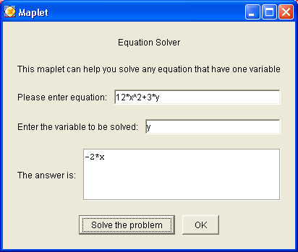

c) 3Dplotter maplet which accept any equation in two variables and draw a 3D plot.
> restart: with(Maplets[Elements]):
> PlotTheMaplet:=Maplet(
Window('title'="3D Plot", 'layout'='BL1'),
BoxLayout['BL1']( BoxColumn(
BoxRow("Enter the equation:"),
BoxRow(TextField['TF1'](2)),
BoxRow("The plotted equation is:"),
BoxRow(Plotter['PL1']()),
BoxRow(Button("Plot The Equation", Evaluate('PL1'='plot3d(
TF1,x=-15..15,y=-20..20)')),
Button("Close",Shutdown(['TF1'])))
))):
> Maplets[Display](PlotTheMaplet);
>
