1. During your laboratory class, you have created multiplots (one figure containing several plots) and animations using these multiplots. Using your own function, create at least one set of multiplot (static) and animation. Use as many options as possible to make your plot look like textbook quality plots.
> restart:with(plots):
Warning, the name changecoords has been redefined

> y:=S*sin(2*i*theta)+S*sin(i*theta);
> p1:=plot(subs(S=2,i=5,y),theta=0..4*Pi, colour=red, legend="S=2", thickness=2):p1:

> p2:=plot(subs(S=4,i=5,y),theta=0..4*Pi, colour=green, legend="S=4", thickness=2):p2:

> p3:=plot(subs(S=6,i=5,y),theta=0..4*Pi, colour=yellow, legend="S=6", thickness=2):p3:

> p4:=plot(subs(S=8,i=5,y),theta=0..4*Pi, colour=blue, legend="S=8", thickness=2):p4:

> p5:=plot(subs(S=10,i=5,y),theta=0..4*Pi, colour=maroon, legend="S=10", thickness=2):p5:

> display(p1,p2,p3,p4,p5);
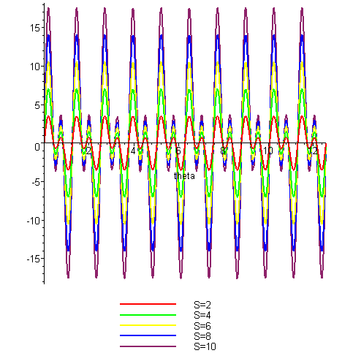

> animate(subs(i=5,y),theta=0..2*Pi,S=2..10,colour=maroon);
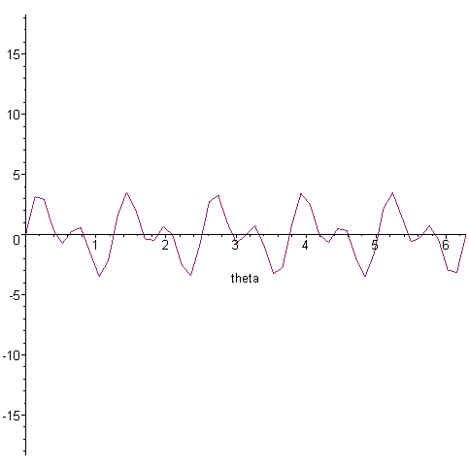

2. Your artistic skills: Draw a unique picture using Maple.
> restart:with(plots):

> L:=s->4^2/149*s;
A:=s->cos(12*s^2)*L(2*s)^3+cos(s^3-12)*15+sin(3*s)*sech(36*s):
> polarplot([A, s->s], numpoints=300,axes=NONE, color=green);
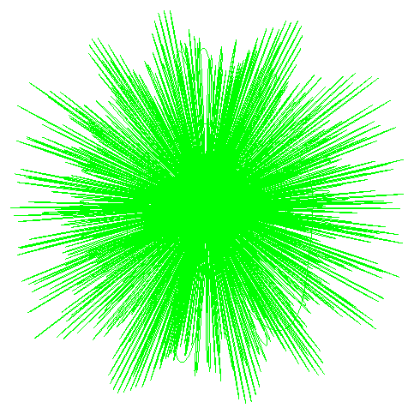

3. Make two unique animations in 2D and 3D.

Give names to these pictures. Publish these pictures and the animations in your home page along with the details, such as the equations that are used to create the animations.
> restart:with(plots):

3D animations
>animate3d(sin(5*x)*sin(12*t*u),x=1..10,t=1..20,u=1/4..8/2,style=wireframe,thickness=2,coords=cylindrical,title="Tree Star");
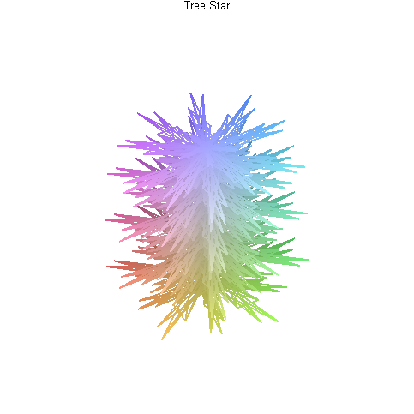
2D animations
> restart:with(plots):
Warning, the name changecoords has been redefined

> animate([cos(27*x^t),x,x=-8..2*Pi],t=1..4,coords=polar,numpoints=100,color=blue,axes=NONE,
thickness=8,title="ROTAVIRUS");
