Question 1
1. Hierarchy of arithmetic operations: Use your own examples (at least three examples and execute them in maple) to prove which arithmetic operations are carried out first in Maple and if they are of equal priority, in which directions they are carried?
> e1 :=(3*12/2-7)*4-2:
> e1; # The equation goes from left to right. The program complete the argument in the parenthesis first. The program does multiplication and division before substract or addition value.
> e2:=5/2*4-2*4+6:
> e2; # The equation goes from left to right. 5 is divided with 2 and multiply with 4. Then, the result was subtracted with the value of 2 multiply by 4. The last result is added with 6.
> e3:=2.5+7*2/4+3^2:
> e3; # The program did the value that have multiplication(*), division(/) and exponential(^) symbol first. Then the value followed the equation from left to right either addition or subtraction.

Question 2
2. Using your own examples (one example each and execute them in maple) clearly bring out all the differences between the following maple symbols and commands:

a) ; and :
b) = and :=
c) ? and ???
d) expression and function
e) sum and add

question_a:
> eqn1:=3*x^2+4*x-3: #the formula will not be display when colon symbol used.
> eqn1:=3*x^2+4*x-3; #the formula will be display when semi colon symbol used.
>
question_b:
> 3*x^2+4*x-3=0; #the equal(=) symbol is used to show the result of the formula
>
> eqn2:=3*x^2+4*x-3; # the colon and equal (:=) symbol is used following expression name
question_c:
> ?graph # the Description ,Example and See Also folder in Help facilities are expand
> ???graph # only Example is expand in Help facilities
>
question_d:
expression
> restart:
> f:=(12*x^2+3*x-4*x^4)/(2*x^4);
> f(5);
> x:=5;
> f;
function
> h:=y->3*y^6-12*y/2+(5*y^4);
> h(3);
> restart:
question_e:
> sum (3*x^200, x=0..infinity); #definite and indefinite summation
> add(3*x^200, x=0..infinity); #add up a sequence of values, only work for numeric ranges, the addition are not able to define

Question 3
3. Use of Help facilties in Maple: Use the help commands in Maple and explain the use of three Maple commands (not discussed in the class) with your own examples.
Command 1: genpoly: genpoly computes the unique polynomial a(x) over Z[x] from the integer n with coefficients less than b/2 in magnitude such that subs(x=b, a(x)) = n. This is directly related to b-adic expansion of an integer. If the base-b representation of the integer n is c0 + c1*b + ... + ck*b^k where ci are integers modulo b (using symmetric representation) then the polynomial generated is c0 + c1*x + ... + ck*x^k . If n is a polynomial with integer coefficients then each integer coefficient is expanded into a polynomial. This polynomial, n, must be in fully expanded form.
> with(ScientificConstants);
> genpoly(21,5,x);
> genpoly(2*y+4*y^3-y^3,5,x);

Command 2: The function anova[oneway] is used to test whether changing the factor has any significant influence, or whether the apparent change could have just as well been due to random fluctuations. Each value of the factor gives rise to one treatment. Each treatment is repeated (or replicated) and the results are put in a list. The data required by anova[oneway] is then a list of all those lists.
> with(stats[anova]):
with(stats[describe]):
Treatment_1:=[ 12, 14, 17 ];
Three of the measures have the same value
> Treatment_2:=[ Weight(12,3), 11];
One bad measure
> Treatment_3:=[ missing, 10, 21, 7, 14 ];
> data:=[ Treatment_1, Treatment_2, Treatment_3 ];
> R:=oneway(data);
The F-ratio is 68/715 with 2 and 8 degrees of freedom.
> Ratio:=%[2];
the level of significance is measured with
> sig:=stats[statevalf,cdf, fratio[Ratio[1], Ratio[2]]](Ratio[3]);
Since this is much smaller than 0.95, we conclude that there is no significance to the differences in means:
> map(mean, [Treatment_1, Treatment_2,Treatment_3] );
> evalf(%);
Now we change the treatment results to yield
> data2:=[[ 10, 11, 8 ], [ Weight(11,3), 13],[ missing, 14, 15, 11, 16 ]]:
Ratio2:=oneway(data2)[2];
The difference between
> map(mean,data2);
> evalf(%);
is significant at the 0.05 level (since 0.976>0.95) but not at the 0.01 level (since 0.976<0.99).
Command 3: The function histogram of the subpackage stats[statplots] plots a bar graph for one or more statistical lists.
> with(stats):
with(stats[statplots]):
data1:=[ Weight(1..3, 5), Weight(3..5, 10), Weight(5..7, 8)]:
histogram(data1, color=cyan);
Warning, these names have been redefined: anova, describe, fit, importdata, random, statevalf, statplots, transform

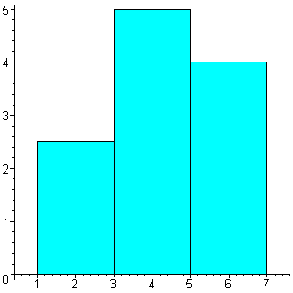

Question 4
4. Use of units and Scientific Constants: Select any three problems involving different types of units from your textbooks and carry out the complete calculations including the units using Maple. State the problem fully and comment whether Maple gives the correct final answer along with appropriate units. (Refer the examples discussed in the class):
> restart:
Example 1
What is the volume of 15g platinum?
> with(ScientificConstants);
> with(Units[Natural]);
> GetConstants();
> GetElement(platinum);
> density:=21.5*g/cm^3;
> mass:=15*g;
> volume:=mass/density;
Example 2
How many hours in one year?
> t:=365*days;
> convert(t,units,hours);
Example 3
How many molecules of glucose in a 100 gram sample?
> glucoseMole:=6*Element(C,atomicweight)+12*Element(H,atomicweight)+12*Element(O,atomicweight);
> evalf(glucoseMole);
> convert(%,units,kg,amu);
> 100./%;
> %*evalf(Constant(N['A']));

Question 5
5. Find out the dimensions of three different physical properties using Maple.
> restart:
> with(Units);
> GetSystems();
> GetDimensions();
> GetDimension(volume_flow);
> GetDimension(acceleration);
> GetDimension(specific_heat_capacity);

Question 6
6. Calculate the volume occupied by 1 kg of mercury at 25 C.
> restart:
> with(ScientificConstants);
> GetElements();
> GetElement(Hg);
> mass:=1000*g;
> density:=13.5336*g/cm^3;
> volume:=mass/density;

Question 7
7. Use Maple to calculate the number of water molecules in 1 g of liquid water.
> restart:
> with(ScientificConstants);
> GetElements();
> waterMole:=2*Element(H,atomicweight)+1*Element(O,atomicweight);
> evalf(waterMole);
> convert(%,units,kg,amu);
> 1./%;
> %*evalf(Constant(N['A']));

Question 8
8. What is computer algebra system and what are its advantages?
Computer algebra system is the system of doing mathematical computation. The advantage of using the systems are:
(i)mathematical problems become easy( sin, cos, statistics, calculus)
(ii) plotting graph with various types and dimension( 2D, 3D, with or without axis, etc)
(iii)can do any physics or chemical calculation without memorizing the constants and such things.
There are lots more advantages of using computer algebra system such as Maple, but you have to find out by ourselves by practising using it and not just read it.
>
>
>

Question 9
9. Determine whether y+8/x-2=x+6 is linear nor not? (Hint: solve for y, and comment)
> (y+8)/(x-2)=x+6;
> solve((y+8)/(x-2)=x+6,y);
> # the equation is not linear because it has x^2 which make the equation quadratic

Question 10
10. Show that z=1, y=2, x=3 are the solutions for x+2y-3z = 4. (Hint: use subs)
> x+2*y-3*z-4=0;
> equation1:=x+2*y-3*z-4;
> subs(x=3, %);
> subs(y=2, %);
>
> subs(z=1, %);
> # z=1, y=2, x=3 are the solutions for the equation given because when the value were substituted into the equation, it is equal to 0
>

Question 11
11. a) Solve the equations: x - y = -3 and x + 2y = 3. Plot these equations in the same graph. Do these graphs cross each other? What is the meaning of the point of intersection? :
> restart:
> with(plots);
>
> e1:=x-y+3;
> e2:=x+2*y-3;
> solve({e1,e2},{x,y});
> y:=x+3;
> a1:=plot(x+3,x=-infinity..infinity):
> a1;
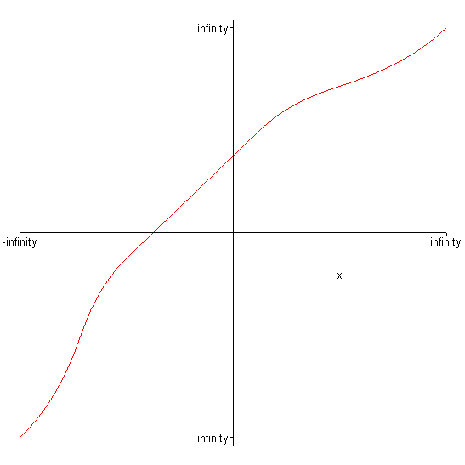
> a2:=plot((3-x)/2,x=-infinity..infinity):
> a2;
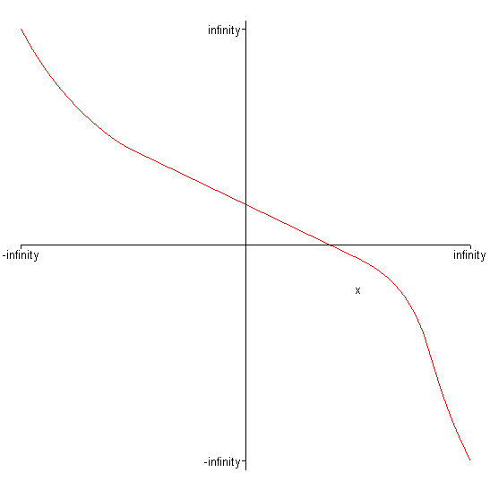
> display(a1,a2);
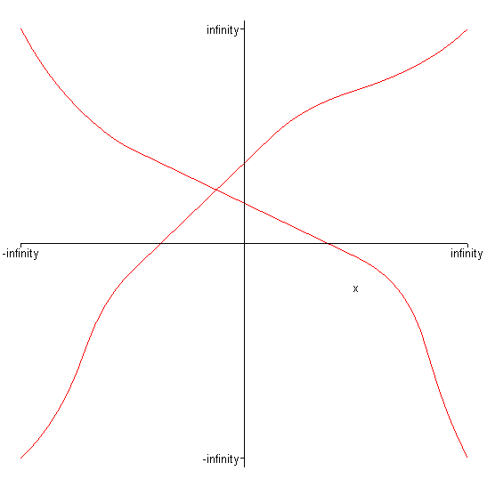
> # The point at the intersection is the value of x and y which can be used to substitute in the equation and gave the same result between a1 and a2.
b) Plot the equations: y = -x - 3 and y = -x + 2. From the graphs what can you say about the existence of solutions for this set of equation?
> restart:
> with(plots);
> y1:=-x-3:
> y2:=-x+2:
> plot({y1,y2},x=-infinity..infinity);
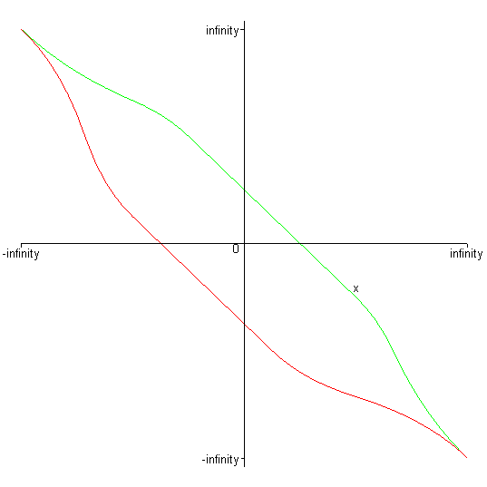
> # The solution for both equations are not the same.As the value approach infinity, the solution for the equations are all the same.
c) Plot the equations: x + y = 1 and 2x + 2y = 2. From the graphs what can you say about the existence of solutions for this set of equation?
> restart:
> with(plots);

> y1:=1-x:
> y2:=(2-2*x)/2:
> plot({y1,y2},x=-infinity..infinity);
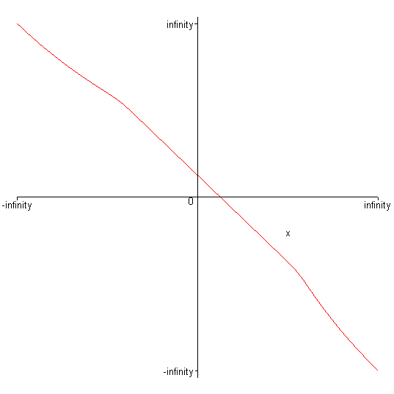
> #the solution for both equation are all the same because the equation lies on the same line

Question 12
12. Solve the equations: 2x + y - 2z = 8, 3x + 2y - 4z = 15 and 5x + 4y - z = 1.
>
> e1:=2*x+y-2*z-8;
> e2:=3*x+2*y-4*z-15;
> e3:=5*x+4*y-z-1;
> solve({e1,e2,e3},{x,y,z});

Question 13
13.Write any equation of your own and expand it using Maple. Factorize and simply the result and show that it gives back the starting equation.
> ((x+y-z)*(3*x-5*y+6*z)^2*(2*x+7*y+3*z)^6)/(x+y+z);
> expand(%);
> factor(%);
> simplify(%);
>

Question 14
14. Write any equation in with three variables (x, y and z) and solve it using Maple.
> restart:
> e1:=3*a+5*b-2*c=4;
> e2:=4*a-b+6*c=12;
> e3:=5*a-4*b-2*c=-3;
> solve({e1,e2,e3},{a,b,c});

